GLA University Mathura


Home automation system using Android Mobile Phone

Mini Project
For
Partial fulfillment of
Btech Computer Science in Engineering
Session (2020-21)

Submitted By:
Pushpraj Singh(191599015)
Mohit Sharma (191599011)
Abhishek Tomar (181500030)
Jaidev Singh (191599006)

Submitted to:
DEPARTMENT OF COMPUTER SCIENCE AND ENGINEERING
G.L.A UNIVERSITY, MATHURA (U.P.)
 | Table of Contents
Acknowledgement............................................................... |  | i
Abstract....................................................................... |  | .…..ii
List of Figures.................................................................. |  | Iii
List of Table..................................................................... |  | Iii
1. Introduction
1.1 | Introduction............................................................. | 1
1.2 | Project Objectives……...... | ……….….....................2
1.3 | Project Scope…………...………………................2
1.4 | Technology exposure that project provides……....3
1.5 | Project Management………..………......………...3

- Literature Review………………………………........5

- Background Theory…………………………….........6

3.1 | Block Diagram of Proposed Design…………… |  | ....6
3.2 | Background………....……………………….......... |  | 7
3.3 | Solution Details…………………………...………9
3.4 | Raspberry Pi | ............................................................ | 9
4. Methodology ................ |  | …………………………...…10
4.1 | Start Mode Activity………………………........... |  | 10
4.2 | Option Mode Activity…………………………....10
4.3 | Voice Mode Activity…………………………..... |  | 11
4.4 | Switch Mode Activity…………………………....11
4.5 | Video Mode Activity………………………......... |  | 11
5. Hardware & Programming Language Description..... |  |  | 12
5.1 | Hardware Description…………………………....12
5.2 | Software Description…………………………..... |  | 13

6. Epilogue.............................. |  | ………………… | ............14
6.1. | Limitation............................................................. |  | 14
6.2. | Discussion............................................................. |  | 14
6.3. | Conclusion............................................................ |  | 14

6.4. Further Enhancement 15

References… 16

Bibliography 17

Appendixes

- Gantt chart

- Raspberry pi GPIO

- Raspberry pi Quick Start Guide
List of Figures

- Waterfall Model……………………………………………...….4

- Gantt Chart…………………………………………………..…..5

3. Block Diagram of Proposed System 7

4. Start Mode Activity………… 11

- Option Mode Activity…………………………...........................11

- Voice Mode Activity…………………………............................12

- Switch Mode Activity…………………………..........................12

- Block Diagram of Hardware Description……………………….13

List of Table

1. Part List with Cost Estimation…………….................................15

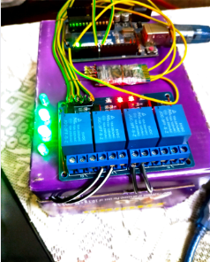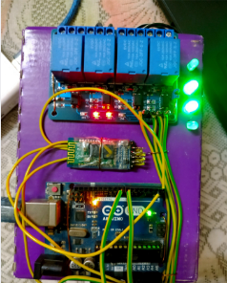

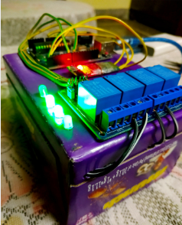

Abstract

This project presents the overall design of Home Automation System (HAS) with low cost and wireless system. This system is designed to assist and provide support in order to fulfill the needs of elderly and disabled in home. Also, the smart home concept in the system improves the standard living at home. . The switch mode and voice mode are used to control the home appliances. The video feedback is received in the android application which streams the video of IP-Camera. The main control system implements wireless technology to provide remote access from smart phone. The design remains the existing electrical switches and provides more safety control on the switches with low voltage activating method. The switches status is synchronized in all the control system whereby every user interface indicates the real time existing switches status. The system intended to control electrical appliances and devices in house with relatively low cost design, user-friendly interface and ease of installation.

ii
1

1. Introduction

1.1. Background

The “Home Automation” concept has existed for many years. The terms “Smart Home”, “Intelligent Home” followed and has been used to introduce the concept of networking appliances and devices in the house. Home automation Systems (HASs) represents a great research opportunity in creating new fields in engineering, and Computing. HASs includes centralized control of lighting, appliances, security locks of gates and doors and other systems, to provide improved comfort, energy efficiency and security system. HASs becoming popular nowadays and enter quickly in this emerging market. However, end users, especially the disabled and elderly due to their complexity and cost, do not always accept these systems.
Things are everything which surrounds human and all those device/appliances which are directly or indirectly playing important role in making life easier by helping in daily activities so as to refine the life style. Some of the appliances such as washing machines, music system, washers, freeze, air conditioner, bike, bicycle, television, fan, light, surveillance camera, utility meters, thermostats, water motor, shower, dryers, printer, car, smart phones, computers, wearable electronics and door lock-unlock etc. Fig. 1 shows different smart things/devices which are easily available in every home environment.

Things/appliances may act as smart things-devices due to their persisting working culture in response to the human action. Devices collective intelligence in collaboration with other devices in surroundings makes them smart enough to interact with controller to receive and transmit data signals to achieve common goal while executing particular action on the behalf of individual operating condition for performing remote sensing actuating and monitoring.

2

1.2. Project Objectives

Android controlled Smart Home Automation should be able to control the home appliances wirelessly with effectively and efficiently.

Controlling Home Appliances via Application (Switch and Voice Mode)

To develop an application that includes the features of switches and voice mode application. Switch Mode or Voice Mode can be used to control the switches of home appliances.

Secure Connection Channels between Application and Arduino Uno

Use of secure protocols over Wi-Fi so that other devices cannot control the appliances. Options for secure connection is SSL over TCP, SSH

Controlled by any device capable of Wi-Fi (Android, iOS, PC)

To make the home appliances flexible in control, any device capable of Wi-Fi connectivity will able to control the home appliances from remote location.

Extensible platform for future enhancement

The application is to be highly extensible, with possibility of adding features in the future as needed.

1.3. Scopes

The project aims at designing a prototype for controlling the home appliances that can be controlled wirelessly via an application that provides the features of speech recognition, video streaming, and switch mode. An application is run on android device. The system can be used in wide range of areas.

The system integrated with different features can be applied in the following fields.

- The system can be used in home, small offices to the big malls

The system can be used from home to offices to control the electrical appliances.
3

- For remote access of appliances in internet or intranet.

The home/office appliances can be controlled in intra-network or can be accessed via internet.

- For the development of technology friendly environment

The system incorporates the use of technology and making smart home automation. By the use of day to day gadgets we can utilize them for different prospective.

1.4. Technology Exposures That Project Provides:

- Google’s Android open source technology.

- Wi-Fi technology.

- Interfacing Wireless Adapter to Arduino Uno.

- Interfacing relays with ac and dc power sources.

- Using Transistor as a Switch.

- Embedded programming.
4

1.5. Project Management

This project constituted development of application as its major part as well as the hardware to control home appliances. Management of any project has several steps or processes in it. So, our projects can be described under the following steps-:
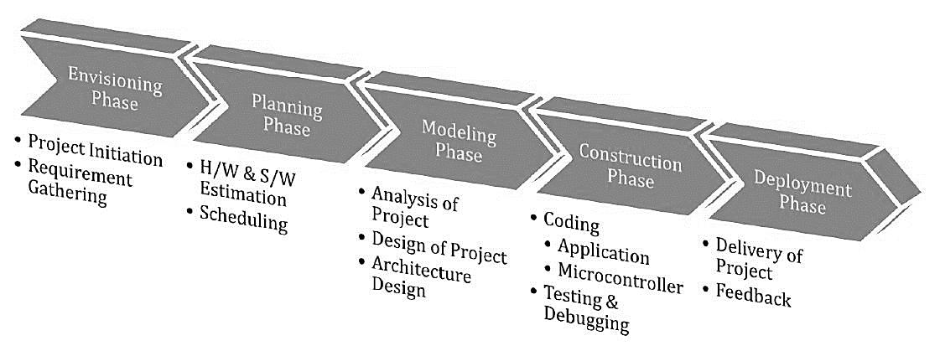

Figure 1: Waterfall Model

1.5.1. Experimentation

In this step, we were discussing about the necessary equipments and materials. We were studying about the similar projects, gathering the information of programming language to be used. We were developing simple algorithms and flowcharts.

1.5.2. Design

In this phase, we were designing the layout of the application. The necessary features to be included. We were designing the power strip to connect the home appliances that can be controlled via GPIO pins.

1.5.3. Development and Testing

In this phase, the development of application was performed. The bugs were identified and removed. We consulted many software experts for the evaluation of our application. Hardware design includes the design of power strip.

1.5.4. Real-World Testing

Finally, our system was ready to be tested in the real electrical appliances.
5
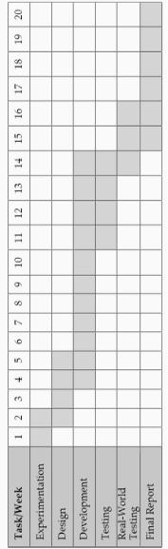

Figure 2: Gantt chart
6

2. Literature Review:

As per our survey, there exist many systems that can control home appliances using android based phones/tablets. Each system has its unique features. Currently certain companies are officially registered and are working to provide better home automation system features. Following models describes the work being performed by others.

N. Sriskanthan [7] explained the model for home automation using bluetooth via PC.

But unfortunately the system lacks to support mobile technology.

Muhammad Izhar Ramli [8] designed a prototype electrical device control system using Web. They also set the server with auto restart if the server condition is currently down.

Hasan [9] has developed a telephone and PIC remote controlled device for controlling the devices pin check algorithm has been introduced where it was with cable network but not wireless communication.

Amul Jadhav [10] developed an application in a universal XML format which can be easily ported to any other mobile devices rather than targeting a single platform.

Each of these system has their own unique features and on comparison to one another lacks some advancement.

Our designed system has application layer prototype. The application is able to synthesize the speech data with the help of Google Voice Reorganization. The synthesized data are analyzed and further processing is carried out. In layman words, our design system provides features of controlling the home appliances using voice commands.

The use of socket programming is performed to connect the android application with the raspberry pi. This further adds security to our system. The data are received only by the server at the specified port and data are further analyzed. Our project is different in a sense it has its own software level application to control the home appliances.
7

3. Block Diagram

3.1. Block diagram of proposed system

Android device |  | Network
(mobile/ tablet) |  | Network
(mobile/ tablet) |  | (Router)
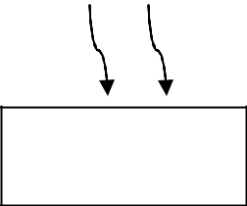



Bluetooth
Module
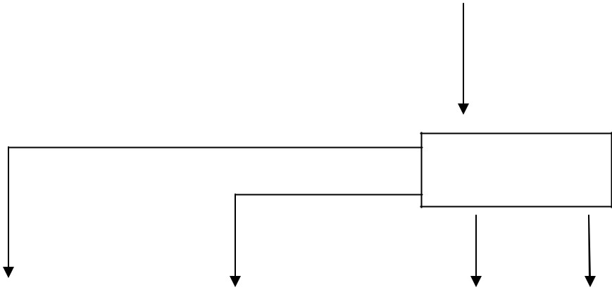

Arduino Uno

 | Relay |  |  | Relay |  | Relay |  |  | Relay
 | Appliance 1 |  |  | Appliance 2 |  | Appliance 3 |  |  | Appliance 4

Figure 3: Block Diagram of Proposed System
8

3.2. Proposed System:

The android OS provides the flexibility of using the open source. The inbuilt sensors can be accessed easily. We have built an application with following features. Android Phone acts as a client and data are sent via sockets programming.

- Switch Mode

- Voice Mode

Switch mode uses the radio buttons that are used to control the home appliances. The radio button sends the status of the switch.

Voice Mode is used to control the home appliances using voice command. Using the inbuilt microphone of Smartphone, the application creates an intent that fetches the speech data to the Google server which responds with a string data. The string data are further analyzed and then processed.

Video Mode shows the video stream of the room. The captured video is streamed at the android application.

All the devices are connected to a common network. Smartphone, raspberry pi and IP camera are connected to the common network Router is used to create a common network.

Wi-Fi Adapter is used to connect raspberry pi to the network. Raspberry pi is used to maintain the server. The pi collects the data analyses it and further activates GPIO pins as necessary. The GPIO pins of raspberry pi are connected to the relay. Relay switch are used to connect the home appliances.

3.3. Solution Details

3.3.1 Hardware Environment

Control electronics

- Arduino Uno as the controller for its processing power and large developer community.

- 4 relays are connected to power strips.
10

- GPIO pins are connected to transistor. Transistors are used as switch.

3.3.2. Software Environment

- Android Developer Tools (ADT)

  - To build the android application to send the control signals to control the robot.

- RPI-GPIO library

  - GPIO interface library for the Raspberry Pi.
11

4. Application Description:

Application Consists of Graphical User Interfaces. It consists of following different activities.

- Start Mode Activity

- Option Mode Activity

- Voice Mode Activity

- Switch Mode Activity

- Video Mode Activity
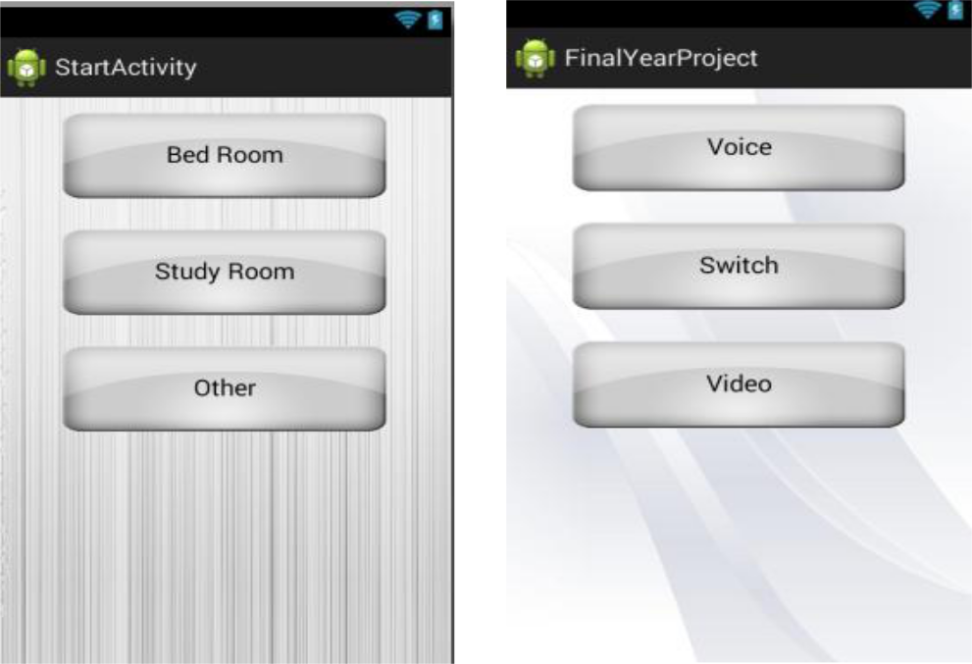

Figure 4.1: Start Mode Activity Figure 4.2: Option Mode Activity

4.1 Start Mode Activity:

In this mode, all the rooms of the home are displayed. The user can select the necessary room from the option to control the appliances connected to specified room.
12

4.2. Option Mode Activity:

This mode provides the user for the option to control. The user can select either switch mode or voice mode to control the appliances.

4.3. Voice Mode Activity:

This mode provides the user to give the speech feedback to the application. The speech data are processed and required appliances are controlled.
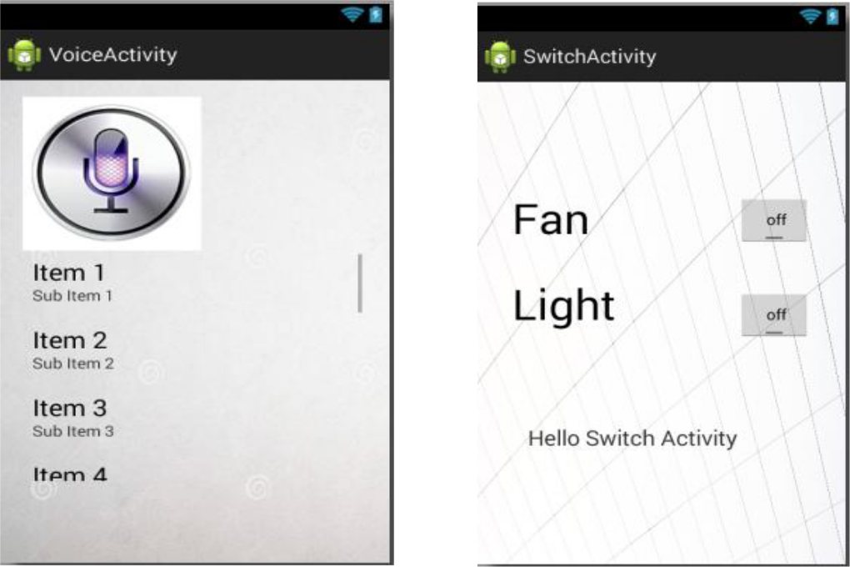

Figure 4.3: Voice Mode Activity Figure 4.4: Switch Mode Activity

4.4. Switch Mode Activity:

This mode provides the user with on/off buttons to control the required home appliances.

4.5. Video Mode Activity:

This mode displays the video of the IP cameras connected at the rooms of the home.
13

5. Hardware and Programming Language Description

5.1. Hardware Description:

The power strip is designed and relays are connected to power strip. The home appliances are connected to the power strip. The Relays are connected to the GPIO pins of the raspberry pi.
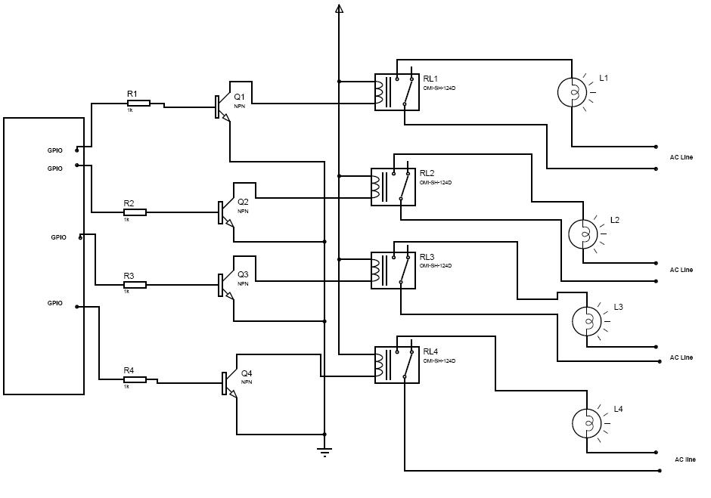

Figure 5: Block Diagram of the Hardware Description
14

5.2. Software Description

We have used two different programming languages for our project. For the development of the application on android, we have used Java Platform. Android Software Development kit incorporates Eclipse software where Java programming is performed.

Eclipse software is used to write the codes for the application under Java Platform. Raspbian OS is used at the raspberry pi. Server is established at raspberry pi. Python Language is used to write the codes of server, and to control the GPIO Pins of OS.

5.2.1. Java:

Java is a set of several computer software products and specifications from Oracle Corporation that provides a system for developing application software and deploying it in a cross-platform computing environment. Java is used in a wide variety of computing platforms from embedded devices and mobile phones on the low end, to enterprise servers and supercomputers on the high end.

5.2.2. Python:

Python is an interpreter, interactive, object-oriented programming language. It incorporates modules, exceptions, dynamic typing, very high level dynamic data types, and classes. Python combines remarkable power with very clear syntax. It has interfaces too many system calls and libraries, as well as to various window systems, and is extensible in C or C++. It is also usable as an extension language for applications that need a programmable interface.Python is a high-level general-purpose programming language that can be applied to many different classes of problems.

5.2.3. Raspbian:

Raspbian is a free Operating System based on Debian optimized for the raspberry pi hardware. Raspbian comes with more than 35000 packages; pre-combined software bundled in a nice format for easy installation on Raspberry pi.

16

7. Scope and Application

This system is designed to assist and provide support in order to fulfill the needs of elderly and disabled in home. Household appliances can be easily controlled via a Mobile/Tablet. Status of light, fan and other electrical appliances can be known. With the help of IP camera, video of rooms or certain area of a house can be recorded. This helps to provide security.

8. Limitations

Android devices having lower API version than 16 requires internet access to convert the speech data to string data. Currently, the application is made for Android Smart Phones; other OS platform doesn’t support our application.

During voice mode, external noises (voice) may affect our result. The speech instruction that we command in our voice mode may not give exact result as expected.

9. Further Enhancements:

Looking at the current situation we can build cross platform system that can be deployed on various platforms like iOS, Windows. Limitation to control only several devices can be removed by extending automation of all other home appliances. Network can be connected to internet and Security cameras can be controlled from other places, allowing the user to observe activity around a house or business. Security systems can include motion sensors that will detect any kind of unauthorized movement and notify the user. Scope of this project can be expanded to many areas by not restricting to only home.
17

10. Conclusion:

The prime objective of our project is to use the Smartphone to control the home appliances effectively. The switch mode and voice mode are used to control the home appliances. The video feedback is received in the android app which streams the video of IP- Camera.

This project is based on the Raspberry pi, Android platform Java and Python. These platforms are Free Open Source Software. So the overall implementation cost is low and can be easily configured.

User can easily interact with the android phone/tablet. The user can send commands via the switch mode or speech mode. The data are being analyzed by the application and are sent over a network. The Raspberry pi acts as a server, analyses the data and activates the GPIO (General Purpose Input Output) Pins. The GPIO Pins are connected to the relays switch which activated the required home appliances.

In this way, automation process is carried out. This is a simple prototype. Using this as a reference further it can be expanded to many other programs.
18

- References

  - https://docs.python.org/

  - http://developer.android.com/training/index.html

  - http://elinux.org/RPi_Hub

  - http://www.raspberrypi.org/

  - http://stackoverflow.com/

  - http://electronics.howstuffworks.com/

  - N. Sriskanthan and Tan Karand. “Bluetooth Based Home Automation

System”. Journal of Microprocessors and Microsystems, Vol. 26, pp.281-289, 2002.

- Muhammad Izhar Ramli, Mohd Helmy Abd Wahab, Nabihah, “TOWARDS SMART HOME: CONTROL ELECTRICAL DEVICES ONLINE”

,Nornabihah Ahmad International Conference on Science and Technology: Application in Industry and Education (2006)

- E. Yavuz, B. Hasan, I. Serkan and K. Duygu. “Safe and Secure PIC Based Remote Control Application for Intelligent Home”. International Journal of

Computer Science and Network Security, Vol. 7, No. 5, May 2007

- Amul Jadhav, S. Anand, Nilesh Dhangare, K.S. Wagh “Universal Mobile Application Development (UMAD) On Home Automation” Marathwada Mitra Mandal’s Institute of Technology, University of Pune, India Network and Complex Systems ISSN 2224-610X (Paper) ISSN 2225-0603 (Online) Vol 2, No.2, 2012
Appendix A: Raspberry Pi GPIO

Introduction

The Raspberry Pi allows peripherals and expansion boards to access the CPU by exposing the in and outputs. The production board has a 26-pin 2.54mm (100mil) expansion header, arranged in a 2x13 strip. They provide 8 GPIO pins plus access to I2C, SPI, UART), as well as +3V3, +5V and GND supply lines. Pin one is column 0 on the bottom row. Voltage levels are 3v3. There is no over-voltage protection on the board - the intention is that people interested in serious interfacing will use an external board with buffers, level conversion and analog I/O rather than soldering directly onto the main board.

It is also possible to reconfigure some of the pins to provide a second I2C interface.

Kernel boot messages go to the UART at 115200bps.

Header Pinout:

5
Top _{V}
Row ₀

Bott 3

om V

Row 3

DN |  | GN |  | TX |  | RX |  | GPI |  | DN |  | GPI |  | GPI |  | DNC |  | GPIO6 |  | SPI_CE |  | SPI_CE
C |  | D |  | D |  | D |  | O1 |  | C |  | O4 |  | O5 |  | DNC |  | GPIO6 |  | 0_N |  | 1_N
SD |  | SC |  | GPI |  | DN |  | GPI |  | GPI |  | GPI |  | DN |  | SPI_M |  | SPI_M |  | SPI_SC |  | DNC
A0 |  | L0 |  | O7 |  | C |  | O0 |  | O2 |  | O3 |  | C |  | OSI |  | ISO |  | LK

Colour legend

+5V

+3.3V

Do not connect

UART

GPIO

SPI

I2C

Power Pins

Maximum permitted current draw from the 3v3 pin is 50mA.

Maximum permitted current draw from the 5v pin is the USB input current (usually 1A)

minus any current draw from the rest of the board.

- Model A: 1000mA - 500mA -> max power draw: 500mA

- Model B: 1000mA - 700mA -> max power draw: 300mA

General Purpose Input/Output (GPIO)

General Purpose Input/Output (GPIO) is a generic pin on a chip whose behaviour (including whether it is an input or output pin) can be controlled (programmed) through software. All the UART, SPI and I2C pins can be reconfigured as GPIO pins, to provide a total of 17 GPIO pins. Each of their functions is detailed in the Broadcom BCM2835 chipset datasheet.

The available alternative functions and their corresponding pins are detailed below. These numbers are in reference to the chipset documentation and may not match the numbers exposed in linux or detailed above. Only fully usable functions are detailed, for some alternative functions not all the necessary pins are available for the functionality to be actually used. All exposed pins can be used for GPIO

Top Row Pinout:
Header | 2 | 4 | 6 | 8 | 10 | 12 | 14 | 16 | 18 | 20 | 22 | 24
Chipset | 14 | 15 | 18 | 23 | 24 | 25 | 8 | 7
Function | 5V0 | DNC | GND | TXD | RXD | PWM | DNC | GPIO | GPIO | DNC | GPIO | SPI_C

Bottom Row Pinout:
Hea | 1 | 3 | 5 | 7 | 9 | 11 | 13 | 15 | 17 | 19 | 21 | 23 | 25
der
Chip | 0 | 1 | 4 | 17 | 21 | 22 | 10 | 9 | 11
set
Func | 3 | SD | SC | GP | D | GP | GP | GP | D | SPI_ | SPI_ | SPI_S | D
tion | V | A0 | L0 | IO | N | IO | IO | IO | N | MOSI | MISO | CLK | N
 | 3 |  |  |  | C |  |  |  | C |  |  |  | C

The complete list of chipset pins which are available are:

0, 1, 4, 7, 8, 9, 10, 11, 14, 15, 17, 18, 21, 22, 23, 24, 25

- Pin 12 supports PWM.

- GPIO voltage level is 3V3 and are not 5V tolerant.

- Each GPIO can interrupt, high/low/rise/fall/change.

It is also possible to reconfigure some of the pins to provide an ARM JTAG interface.

However ARM_TMS isn't available for this (chipset pin 12 or 27 is needed).

It is also possible to reconfigure some of the pins to provide an I2S (hardware mod may be required) or PCM interface.

MIPI CSI-2

The MIPI CSI-2 interface to a 15-way flat flex connector is Sony sub-LVDS.

DSI

The DSI interface to a 15-way flat flex connector.

CEC

HDMI-CEC (Consumer Electronics Control for HDMI) is supported by hardware but some driver work will be needed and currently isn't exposed into Linux userland.
Appendix B: Raspberry Pi Quick Start Guide

Quick Start Guide

The Raspberry Pi – Single Board Computer

Source: Raspberry Pi & Wiki

Chapter 1: RPi Hardware Basic Setup

Typical Hardware You Will Need

While the RPi can be used without any additional hardware (except perhaps a power supplyof some kind), it won't be much use as a general computer. As with any normal PC, it is likely you will need some additional hardware. The following are more or less essential:

Raspberry Pi board

Prepared Operating System SD Card

USB keyboard

Display (with HDMI, DVI, Composite or SCART input)

Power Supply

Cables

Highly suggested extras include:

USB mouse

Internet connectivity- a USB WiFi adaptor (Model A/B) or a LAN cable (Model B)

Powered USB Hub

Case

Connecting Together

You can use the diagram to connect everything together, or use the following instructions:

- Plug the preloaded SD Card into the Pi.

- Plug the USB keyboard and mouse into the Pi, perhaps via a USB Hub. Connect the Hub to power, if necessary.
- Plug the video cable into the screen (TV) and into the Pi.

- Plug your extras into the Pi (USB WiFi, Ethernet cable, hard drive etc.). This is whereyou may really need a USB Hub.

- Ensure that your USB Hub (if any) and screen are working.

- Plug the power source into the main socket.

- With your screen on, plug the other end of the power source into the Pi.

- The Pi should boot up and display messages on the screen.

It is always recommended to connect the MicroUSB Power to the unit last (while mostconnections can be made live, it is best practice to connect items such as displays/h/w pinconnections with the power turned off).

The RPi may take a long time to boot when powered-on for the first time, so be patient!

Prepared Operating System SD Card

As the RPi has no internal storage or built-in operating system it requires an SD-Card that isset up to boot the RPi.

You can create your own preloaded card using any suitableSD card you have. Be sureto backup any existing data on the card.

Preloaded SD cards will be available from the RPi Shop.

This guide will assume you have a preloaded SD card.

Keyboard & Mouse

Most standard USB keyboards and mice will work with the RPi. Wireless keyboard/miceshould also function, and only require a single USB port for an RF dongle. In order to use a

Bluetooth keyboard or mouse you would need to use a Bluetooth dongle, which again uses asingle port.

Remember that the Model A has a single USB port and the Model B only has two (typically akeyboard and mouse will use a USB port each).
Display

There are two main connection options for the RPi display, HDMI (high definition)and Composite (low definition).

HD TVs and most LCD Monitors can be connected using a full-size 'male' HDMIcable, and with an inexpensive adaptor if DVI is used. HDMI versions 1.3 and 1.4 aresupported, and a version 1.4 cable is recommended. The RPi outputs audio and videovia HMDI, but does not support HDMI input.

OlderTVs can be connected using Composite (a yellow-to-yellow cable) or via SCART (using a Composite to SCART adaptor). PAL and NTSC TVs are supported. When using composite video, audio is available from a 3.5mm (1/8 inch) socket, andcan be sent to your TV, to headphones, or to an amplifier. To send audio your TV,you will need a cable which adapts from 3.5mm to double (red and white) RCAconnectors.

Note: There is no VGA output available, so older VGA monitors will require anexpensive adaptor.

Using an HDMI to DVI-D (digital) adaptor plus a DVI to VGA adaptor will not work. HDMIdoes not supply the DVI-A (analogue) needed to convert to VGA - converting an HDMI or

DVI-D source to VGA (or component) needs an active converter. (It can work out cheaper tobuy a new monitor.) The lack of VGA has been acknowledged as a priority issue.

Power Supply

The unit uses a Micro USB connection to power itself (only the power pins are connected

– soit will not transfer data over this connection). A standard modern phone charger with a micro-USB connector will do, but needs to produce at least 700mA at 5 volts. Check your powersupply's ratings carefully. Suitable mains adaptors will be available from the RPi Shop andare recommended if you are unsure what to use.

You can use a range of other power sources (assuming they are able to provide enoughcurrent ~700mA):

Computer USB Port or powered USB hub (will depend on power output)

Special wall warts with USB ports

Mobile Phone Backup Battery (will depend on power output) (in theory – needsconfirmation)

To use the above, you'll need a USB A 'male' to USB micro 'male' cable - these are oftenshipped as data cables with MP3 players.

Cables

You will probably need a number of cables in order to connect your RPi up.

- Micro-B USB Power Cable

- HDMI-A or Composite cable, plus DVI adaptor or SCART adaptor if required, toconnect your RPi to the Display/Monitor/TV of your choice.

- Audio cable, this is not needed if you use a HDMI TV/monitor.

- Ethernet/LAN Cable

Additional Peripherals

You may decide you want to use various other devices with your RPi, such as Flash Drives/Portable Hard Drives, Speakers etc.

Internet Connectivity

This may be an Ethernet/LAN cable (standard RJ45 connector) or a USB WiFi adaptor. TheRPiethernet port is auto-sensing which means that it may be connected to a router or directlyto another computer (without the need for a crossover cable).

USB-Hub

In order to connect additional devices to the RPi, you may want to obtain a USB Hub, whichwill allow multiple devices to be used.

It is recommended that a powered hub is used - this will provide any additional power to thedevices without affecting the RPi itself.

USB version 2.0 is recommended. USB version 1.1 is fine for keyboards and mice, but maynot be fast enough for other accessories.

Case

Since the RPi is supplied without a case, it will be important to ensure that you do not use itin places where it will come into contact with conductive metal or liquids, unless suitablyprotected.

Expansion & Low Level Peripherals

If you plan on making use of the low level interfaces available on the RPi, then ensure youhave suitable header pins for the GPIO (and if required JTAG) suitable for your needs.

Also if you have a particular low-level project in mind, then ensure you design in suitableprotection circuits to keep your RPi safe.

View publication stats

